FOR IMMEDIATE RELEASE
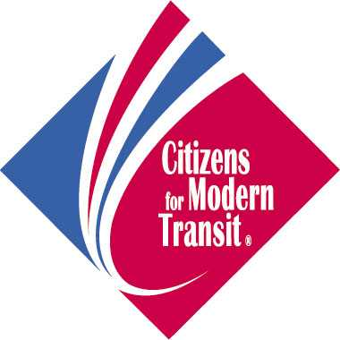
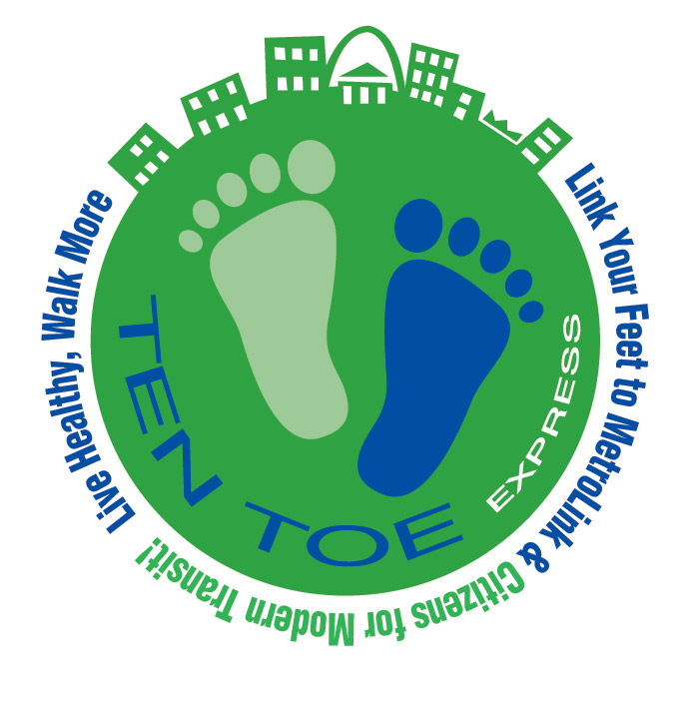
For more information, contact:

Kelly Harris Tom Shrout/Kim Cella
The Hauser Group Citizens for Modern Transit
314-436-9090 314-231-7272

CITIZENS FOR MODERN TRANSIT TARGETS WORKDAY COMMUTERS
WITH ITS HIGHLY-SUCCESSFUL TEN TOE EXPRESS PROGRAM

Commuter Event Set for Sept. 11 at the Shrewsbury, North Hanley and Central West End MetroLink Stations

ST. LOUIS, Aug. 12, 2007 … With over 4500 participants, Citizens for Modern Transit’s (CMT) Ten Toe Express Program has proven its popularity. Now, the program is seeking to further its reach among St. Louis’ employee commuter population through a fall promotion. Area workday commuters who register online for the Ten Toe Express Program at www.cmt-stl.org between now and September 10 can bring their registration confirmation form to CMT’s Commuter Kick-off Event to receive a FREE Ten Toe Express Walking Kit. This event, filled with freebies and fun, will be held simultaneously at the Shrewsbury, North Hanley and Central West End MetroLink Stations from 6:30 a.m. to 8:30 a.m. on Sept. 11.

“With higher food and fuel prices and the continuing I-64 construction project, people are more interested than ever in alternative modes of transportation,” said Tom Shrout, executive director of Citizens for Modern Transit, the organization spearheading the Ten Toe Express initiative. “This free program helps commuters better familiarize themselves with our community’s integrated public transportation system so they utilize it, along with their own ten toes, to get to and from work and around town. We are excited about the kick-off event and encourage workday commuters to pre-register and make plans to attend.”

The Ten Toe Express Commuter Kick-off Event will take place at the three of the most utilized MetroLink stations during the morning commute. Each will serve as point for pre-registered commuters to pick up their FREE Ten Toe Express Walking Kits. However, the Shrewsbury station will serve as the site for the main event. Here, there will be music and giveaways via a live remote by a popular morning radio station, the opportunity to play “drinko” and sample VitaminWater and a chance to win other freebies that promote health and wellness courtesy of the St. Louis Regional Clean Air Partnership, IronWorks Fitness, Gold’s Gym and more.

The mission of the Ten Toe Express Program is to help increase the number of individuals who integrate walking with public transit use, while promoting the health and well-being benefits of doing so. It is focused, in part, on weekly Ten Toe Express Walking Tours, led by a trained Ten Toe leader. The walks allow participants to see how easy it is to step out and enjoy different St. Louis destinations by foot, light rail and bus. Area employees can join one of the Lunch-Hour Commuter Walk Groups, or they can simply round up co-workers and hit the streets for a lunchtime walk or hop on the MetroLink and head to a nearby community that offers refreshing scenery for their mid-day excursion.

-more-

TEN TOE EXPRESS TARGETS COMMUTERS
FIRST AND FINAL ADD

This is made easier thanks to the FREE Ten Toe Express Walking Kits given to all program participants which includes a free tote bag, a walking/bicycling map of the St. Louis area, a pedometer, weekly walk logs and food diaries, a new and expanded coupon booklet with $200 worth of savings, MetroLink tickets and the book titled, “Get on Board the Ten Toe Express and Walk into a healthier you!” The book features a walking checklist to ensure walkers have everything they might need before they hit the pavement; tips on stretching, walking form, choosing workout attire and using a pedometer; and nutritional information. There is also a newly expanded listing of suggested indoor walking destinations and their hours of operation, the rail and bus routes serving those locations and references for measuring the length of those specific walks.

One area workday commuter who is already benefiting from the Ten Toe Express Program commented on it stating, “I was so impressed with the information received through the program, that I have given up my parking spot and I am utilizing the MetroLink for my commute back and forth to work, as well as for my pleasure,” stated JoAnn Brown, Ten Toe Express Program participant and employee at the Charles L. Crane Agency. “I am also walking at least a quarter of mile to and from the station. I don’t think I would have made this move if not for the knowledge I obtained from your organization.”

Those interested in learning more about CMT’s Ten Toe Express or registering for the program can do so by visiting www.cmt-stl.org or calling (314) 570-9652. Funding for this project is provided in part by the Missouri Foundation for Health and the East-West Gateway Council of Governments.

Citizens for Modern Transit is a not-for-profit organization in St. Louis whose mission is to expand the light rail system in order to build more sustainable, accessible communities in the region. Funding for this project is provided in part by the Missouri Foundation for Health and the East-West Gateway Council of Governments. The Missouri Foundation for Health is a philanthropic organization whose vision is to improve the health of people in the communities it serves.

# # #

