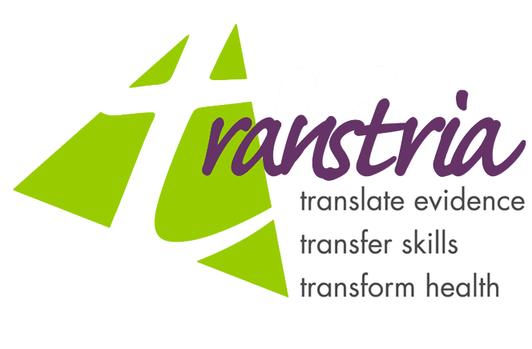
Contact: Julie Claus of Transtria – 314.781.1562
Re: Intervention MICA, government commissioned public health system for Missouri
December 23, 2003
Immediate Release

Intervention MICA: An Evidence-Based Intervention Planning System for Missouri

How can you improve the health of your community? The Missouri Department of Health and Senior Services has contracted Transtria L.L.C. to develop an interactive, evidence-based public health intervention planning system named “Intervention MICA” (Missouri Information for Community Action). This is the third in a series of MICA systems (succeeding Assessment MICA and Priorities MICA). Funding from the Missouri Foundation for Health will support project development for three years, with a total of eight intervention topics to be developed, such as diabetes, physical activity, nutrition, asthma and tobacco.
This web-based intervention planning system will provide information, tools and resources for intervention design, implementation and evaluation. It is guided by a seven step evidence-based approach, including creating partnerships, defining populations, assessing readiness, building capacity, developing interventions, conducting evaluation and maintaining momentum.
The goal of the MICA system is to support communities in their efforts to improve health. Links, toolbars and clear wording will make the system easily navigable for community health organizations, as well as local public health agencies, funding agencies, health care organizations, schools, and faith-based organizations, among others.
Intervention MICA prides itself on being the first intervention planning system that will take its users through the process of developing, implementing and evaluating evidence-based interventions as well as being accessible to a wide variety of users, both familiar with public health practices and lay individuals interested in intervening to improve health.
###

